Problem Statement: There can be multiple customers, who can place multiple orders on the site. Now a sales person can handle these orders will distribute into multiple sales persons (One order will be assign to one salesperson only). So a sales person can have multiple orders of multiple customers

1. Create Database

**create database assign;**

**show databases;**

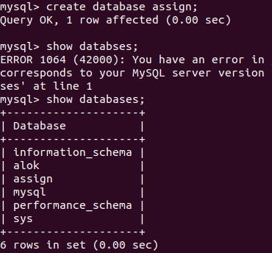

1. Design Schema

**desc CUSTOMER;**

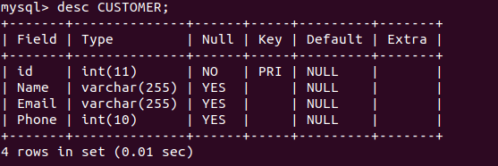

**desc salesman;**

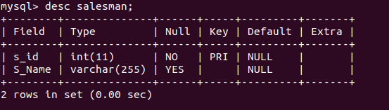

**desc orderstable;**

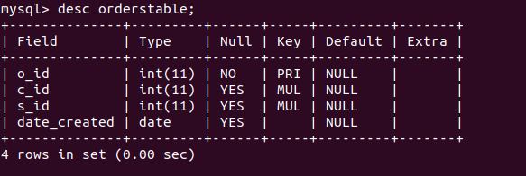

1. Create tables

**CREATE TABLE CUSTOMER(id int, Name varchar(255), Email varchar(255) , Phone int(10), primary key(id));**



**CREATE TABLE salesman(s_id int primary key, S_Name varchar(255));**



**CREATE TABLE orderstable(o_id int primary key ,c_id int,s_id int, date_created date, foreign key (c_id) references CUSTOMER(id), foreign key (s_id) references salesman(s_id));**

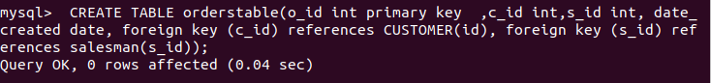

1. Insert sample data

**INSERT INTO CUSTOMER values (1, 'alok mishra' ,'alok@gmail.com', 99585249);**



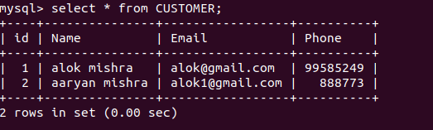

**INSERT INTO salesman values(1,’prabhav’);**

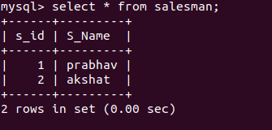

**INSERT INTO orderstable values (2, 1 ,1, '2025-05-02');**

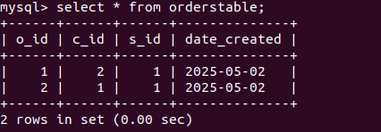

1. Find the sales person have multiple orders.

**select salesman.s_name, count(orderstable.o_id) from salesman left join orderstable on salesman.s_id = orderstable.s_id group by salesman.s_id having count(orderstable.o_id) > 1;**

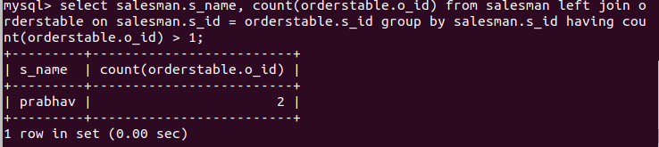

1. Find the all sales person details along with order details

**select * from salesman left join orderstable on salesman.s_id = orderstable.s_id;**

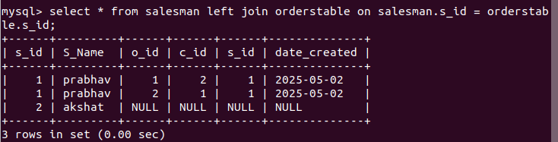

1. Create index

**create index ind on CUSTOMER(Name);**

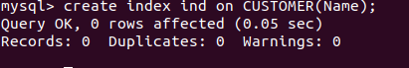

1. How to show index on a table

**Show index from CUSTOMER;**

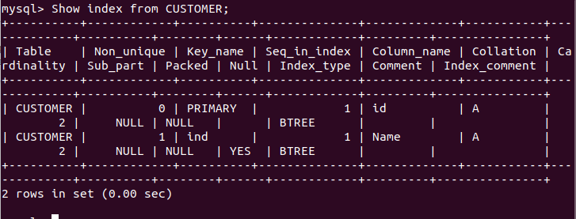

1. Find the order number, sale person name, along with the customer to whom that order belongs to

**Select orderstable.o_id,salesman.S_Name,CUSTOMER.Name,CUSTOMER.Email, CUSTOMER.Phone from orderstable left join salesman on salesman.s_id = orderstable.s_id left join CUSTOMER on CUSTOMER.id=orderstable.c_id;**

